CIS 1051 Python Loop Lab

For this lab, you shall write a (non-turtle) program that has a user interaction inside of a for loop.

Requirements:

After printing a title, your program shall ask the user how many interactions they would like.
- The user’s numeric input shall be validated using a validation loop with a try/except block inside. To test the validation, you repeatedly enter a non-number. The code shall continue to provide an error message and ask for input until you finally enter in a number.

Then, you’ll have a for loop with the user interaction inside. For the user interaction, the user shall be asked to enter some input and the computer shall respond with an output.
- The input could be one or more strings and/or one or more numbers.
  - Any numeric input shall be validated using a validation loop with a try/except block inside (as mentioned above)
- The output of the interaction can be based on the user’s input and/or a random number.

At the end of the program, you will print a summary of something related to the user interactions (e.g., a count, sum, average, minimum, or maximum of some aspect of the user interaction). For example, you might have counted how many correct answers the user provided. You could give the average of values entered by the user. You could list the highest and/or lowest score.

Somewhere (before the user interaction, after the user interaction, or part of the user interaction) the program shall ask the user to enter a string that must be from a short list of values (e.g., PA, NY, NJ). The string shall be validated using a loop. This string shall have some “impact” to your program. In other words, the string shall either affect your calculation or it shall affect which code blocks are executed (e.g., if/else).

Wherever appropriate, output (such as dollar amounts, percentages) is displayed using the format function.

As always, use good programming style:
- If necessary/appropriate, create named “constants” (using the ALL_CAPS naming convention). Do not use any “magic numbers”.
- Select self documenting variable names (using camelCase naming convention).
- Add comments at the top of your program to indicate your name, a program description, and date written.
- Break up your programs into “paragraphs” (blank line between “paragraphs”) where each paragraph is focusing on a sub-task of your overall program. Put a comment before each “paragraph” indicating what is happening in that “paragraph”.
How to validate numeric input using a try/except inside a while loop:

Here is an example of how to force the user to enter an integer that is 1 or greater. Notice how we use a while loop with a try/except inside. This program keeps asking the user for a whole number (1 or greater) as long as the user types in a non-number or anything lower than 1. Try it out ! Can you figure out a way to make the user enter any integer (i.e., 0 and negative acceptable)? Hint: don’t use “num” in the while condition – use another variable to keep track of whether the input is bad or good.
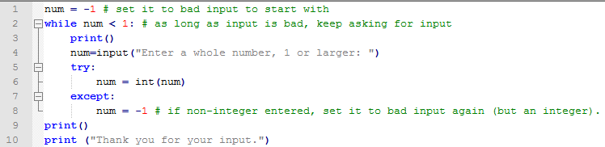

Difference from last lab - how you validate user input

Last lab you had one big “try” block around all your code (input, conversion, calculation, and output). This was OK, but it had a couple of problems:
- First, the except block didn’t tell the user which input was bad – it just knew one of the inputs was bad.
- Second, the user would have to re-rerun the program if they entered bad input.

This week, will your program will follow each input with a validation loop (user cannot proceed until they enter a correct value), then proceed to the calculations and output.

How to validate that a string is one of a list of values using a while loop:

A while loop can also be used to validate character input. Because we do not have to convert character input to numeric (int or float), there is no chance for an exception to be thrown, so a try/except block is not appropriate. The while loop approach is the same, as long as the user enters incorrect input, we just keep asking them for the correct input.
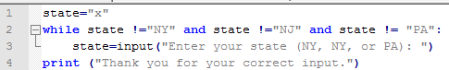

Example of using a random number for a user interaction:

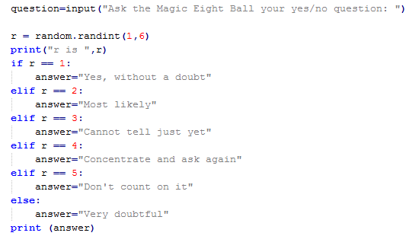

Note: use of random number is not required, but it can make your program more interesting/fun.

Example asking the user how many interactions they want (followed by a for loop):

Then use the python “for” statement so that that your interaction happens as many times as the user wanted, like so:
# Then put your interaction (whatever you choose) here, (indented) inside the for loop.
# Make the interaction happen as many times as the user said they wanted it to happen.

Note1: in the above python “for” statement above, i becomes 0 (the first value in the parentheses) and then i increments by 1 each time through the for loop, so, it is 1, 2, 3, …, but the last time, i is not numQuestions (the second value in the parentheses) - it is 1 less than “numQuestions”. This is just how python works.
Note2: the above example, did not show a while loop validating that numQuestions must be an integer greater than 0. One of the requirements for this lab is that you need to add that (before the for loop starts).

Example summarizing the user interaction:

One of the requirements is that you summarize the user interactions. To do this, you must initialize some variable (for example a total). Then, during the loop, you will modify the variable (for example, add something into the total). Then, at the end of the loop, you will print out the total. It is a good idea while you are debugging to print the total inside the loop, so you can see how its value is changing.
For example, if you were doing the math facts, you could count how many the student got correct. If you were asking the user for item price and quantity purchased, you could add their purchase into a total amount.
# your for loop goes here
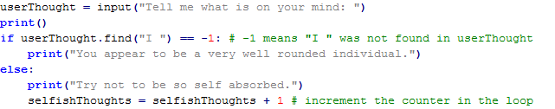
# print your summation variable(s) here, after the loop.

How should you approach this problem? One way would be “bottom up”

If you are using a bottom up approach, you’d start out by coding (& testing) the interaction code, then adding the for loop code around that (& testing), then adding the summarization after that (& testing).

Another approach would be “top down”

With a top down approach, you’d start out coding the for loop with nothing much inside for example you might print “an interaction” and you’d just be sure that happened the right number of times. Then, you’d begin building the details of the interaction.

Regardless of “bottom up” or “top down”, Test Often

Be sure that you run your program very often. Why? If you write only a couple of lines of code, between each test run, then the error is usually in those two lines of code and so easy for you to correct.

Homework submission into the BB assignment (like previous labs):
- Attach a word document (named with your name and “lab4 loops.doc”). In the word document copy/paste your python code, followed by and your test case (see below).
  - This week, you only need one test case. For each input, enter bad data at least twice before putting in acceptable data, then run the program out to completion.
- Also attach your actual python program (named with your name and “Lab4Loops.py”).

Summary of requirements:
Outline of your program:
- A title is displayed at the beginning of running your program.
- You ask the user how many interactions they want to have. Don’t let them proceed until they have entered a number. Keep giving an error message and asking for input as long as they keep entering non-numbers.
- You initialize any count or summary variables.
- Your program has a for loop with an interaction inside.
  - Each interaction takes some user input and provides some output.
    - The input can be one or more strings and/or one or more numbers.
    - The output is calculated based on the user’s input and/or a randomly generated number.
  - Each interaction affects the count or summary variable(s) initialized above.
- After the for loop, the count or summary is displayed.
Other requirements:
- Every number that is to be input has its own validation while loop with try/catch inside.
- Somewhere in the program, at least one string input is validated to be from among a short list of values. This input must be validated with a while loop that has an if statement inside (not try/catch because string input does not throw an exception). This string input has to impact something, e.g., it must either affect the output of the interaction, or it must be tested by if/elif/else so that it affects which block of code is run.

